Experiment 10

1. Aim
To understand and design Business Intelligence deployment, monitoring, backup, and recovery strategies using Microsoft Power BI for ensuring availability, reliability, and continuity of BI solutions.

2. Objectives
- Understand BI deployment and maintenance requirements.
- Identify reports, dashboards, datasets, and other BI assets for deployment.
- Design a workspace structure and assign responsibilities.

3. Tools / Software Required
- Microsoft Power BI Desktop
- Microsoft Power BI Service
- Global Superstore Dataset.xlsx
- Microsoft Excel

4. Theory
Business Intelligence systems must be deployed, monitored, maintained, and protected to ensure continuous business operations. BI Deployment refers to making reports, dashboards, and analytical solutions available to end users. Monitoring involves tracking system performance, usage, refresh status, and operational health. Backup and Restore mechanisms protect BI assets from accidental deletion, corruption, or system failures. Effective deployment and maintenance strategies improve reliability, security, and business continuity.

Business Scenario
Global Superstore has successfully developed reports, dashboards, analytical solutions, security policies, and automated reporting mechanisms. The management team now wants to deploy the BI solution across the organization, monitor its usage and performance, and establish backup and recovery procedures. Students will act as BI Solution Architects and design a complete deployment and maintenance strategy.

5. Procedure

Part A: BI Deployment Planning

Step 1: Create a BI Deployment Plan
- Open your existing Global Superstore .pbix file.
- Go to Home → Enter Data.
- Enter this table:
BI Asset | Description | Intended Users | Deployment Priority
Sales Dashboard | Displays sales performance | Sales Team | High
Profit Dashboard | Displays profitability | Finance Team | High
Executive Dashboard | Displays overall business performance | CEO | High
Regional Report | Displays region-wise sales and profit | Regional Managers | Medium
Global Superstore Dataset | Contains business transaction data | BI Team | High
- Name the table BI_Deployment_Plan.
- Click Load.
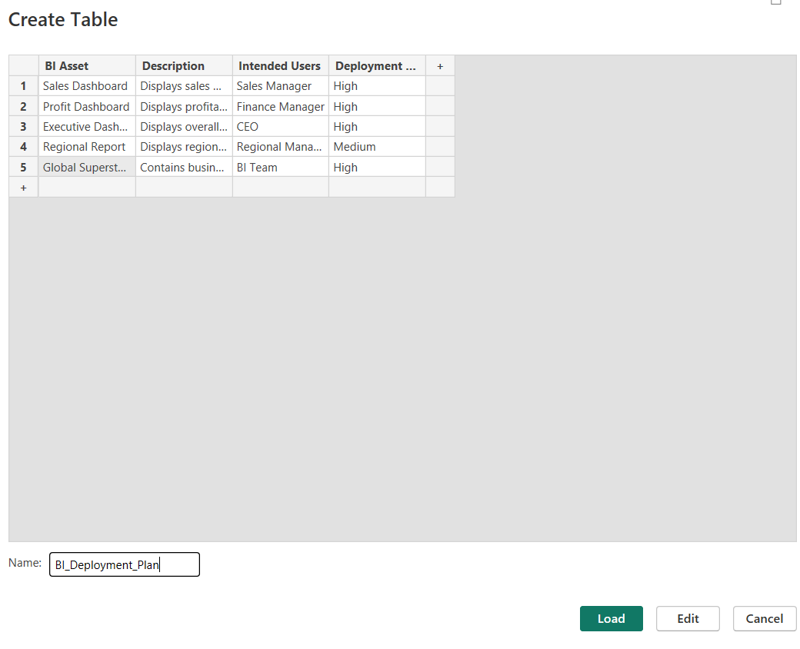

Step 2: Identify deployment objectives
Record these objectives in your practical report:
- Make BI reports available to authorized users.
- Ensure accurate and reliable business information.
- Provide department-specific reports.
- Maintain data security and accessibility.
- Support faster business decision-making.

Part B: Workspace and Access Planning

Step 3: Create the Workspace and Role Structure
- Go to Home → Enter Data.
- Enter the following table:
Workspace Role | Responsibilities | Access Level
Administrator | Manage workspace, users and settings | Full Control
Member | Manage content and collaborate | Edit and Share
Contributor | Create and modify reports | Edit Content
Viewer | View published reports | Read Only
- Name the table Workspace_Roles.
- Click Load.
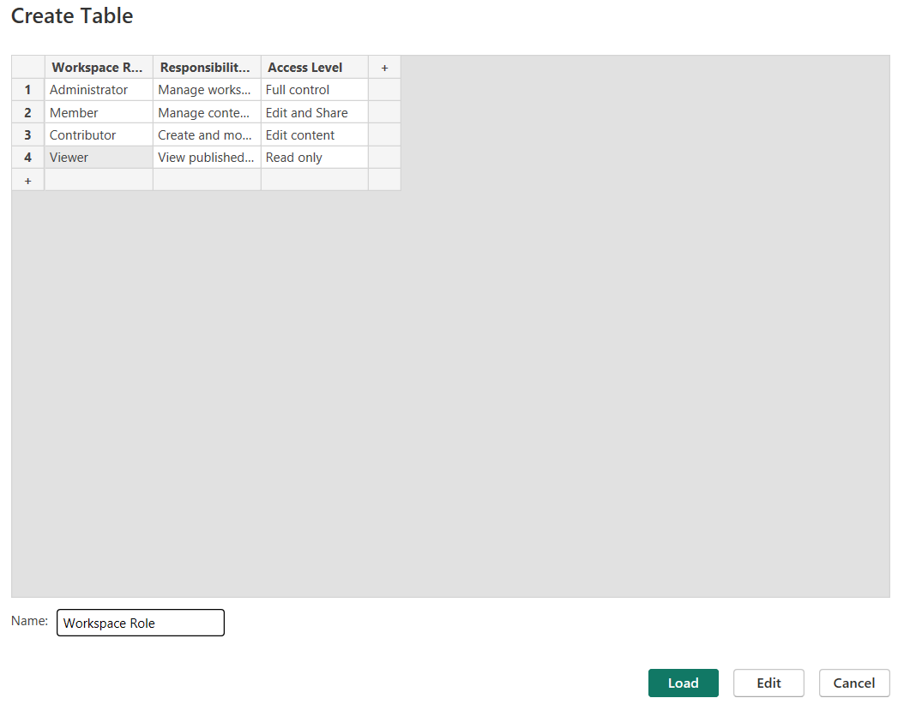

Part C: Monitoring Strategy Design

Step 6: Create a Monitoring Matrix
- Go to Home → Enter Data.
- Enter the following table:
Monitoring Metric | Monitoring Frequency | Responsible Person | Purpose
Dataset Refresh Status | Daily | BI Administrator | Ensure data is updated
Dashboard Usage | Weekly | BI Analyst | Track dashboard usage
Report Performance | Weekly | BI Administrator | Identify slow reports
User Activity | Daily | Security Administrator | Monitor user access
Data Accuracy | Monthly | Data Analyst | Verify data correctness
- Name the table Monitoring_Matrix.
- Click Load.
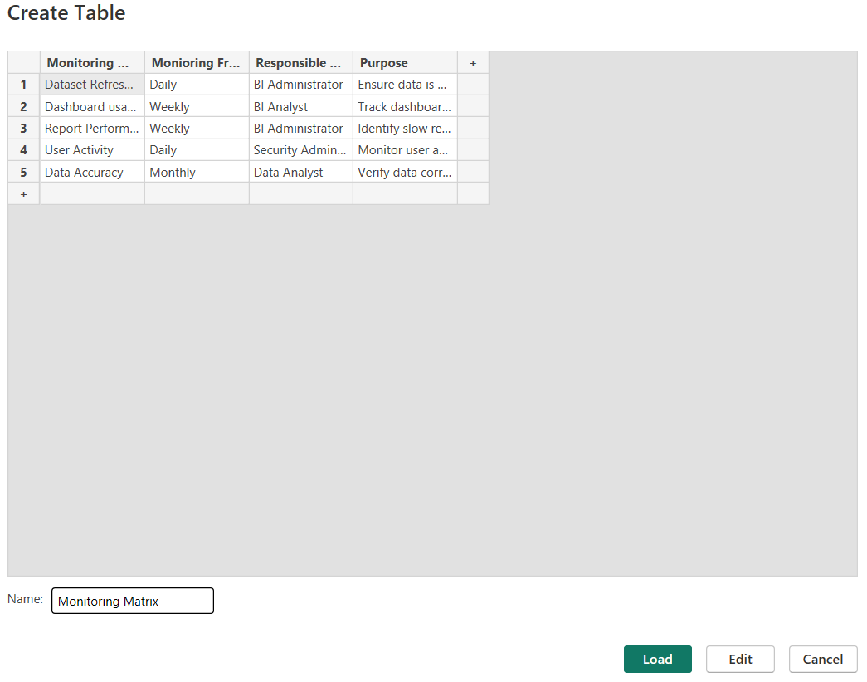

Step 7: Create a Monitoring Dashboard
Create a new report page by clicking the + icon at the bottom.
Create these visuals:
Visual 1: Monitoring Frequency
- Visual: Clustered Column Chart
- X-axis: Monitoring Frequency
- Y-axis: Count of Monitoring Metric
- Title: Monitoring Frequency Analysis
Visual 2: Responsible Personnel
- Visual: Clustered Bar Chart
- Y-axis: Responsible Person
- X-axis: Count of Monitoring Metric
- Title: Monitoring Responsibilities

Visual 3: Monitoring Details
- Visual: Table
- Add Monitoring Metric, Monitoring Frequency, Responsible Person, and Purpose.
- Title: BI Monitoring Overview
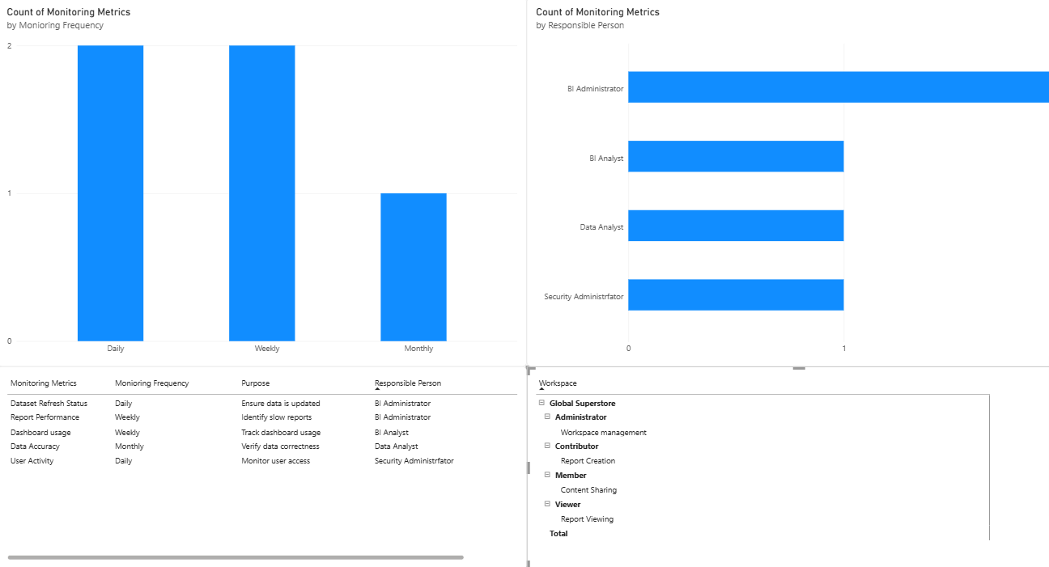

Part D: Backup and Restore Planning

Step 8: Create a Backup Schedule
- Go to Home → Enter Data.
- Enter this table:
BI Component | Backup Frequency | Backup Method |  | Responsible Person
Dataset | Daily | Save a backup copy of Excel data | Data Administrator
Power BI Report | Weekly | Save a copy of PBIX file | BI Developer
Workspace Configuration | Monthly | Maintain configuration records | BI Administrator
Dashboard | Weekly | Keep a copy of the PBIX report | BI Developer
- Name the table Backup_Schedule.
- Click Load.
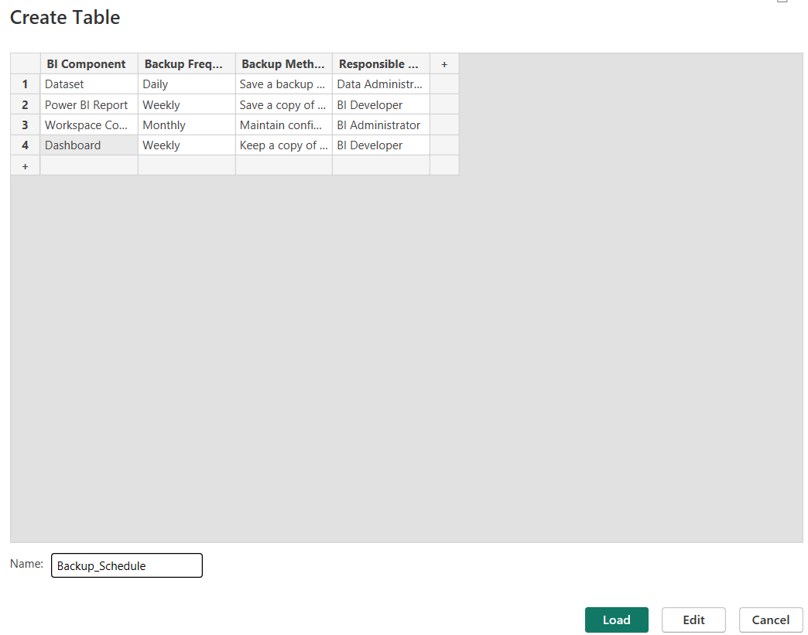

Step 9: Create a Restore Procedure Table
- Go to Home → Enter Data.
- Enter:
Failure Scenario | Recovery Procedure | Expected Outcome
Accidental Report Deletion | Restore the saved PBIX file | Report recovered
Dataset Corruption | Restore the original Excel dataset | Data recovered
Incorrect Report Changes | Open the previous PBIX backup | Previous version restored
System Failure | Recover files from backup storage | BI solution restored
- Name the table Restore_Procedure.
- Click Load.

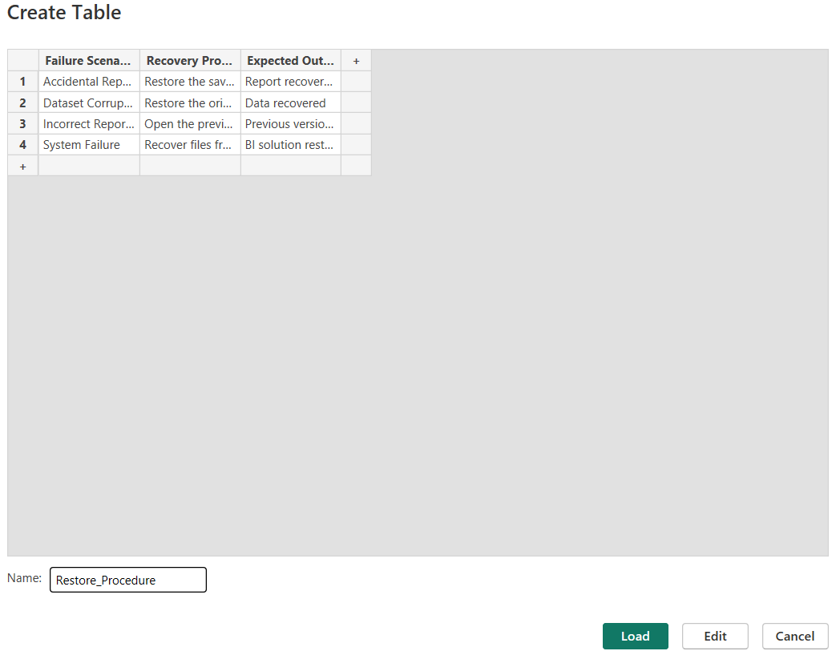

Final BI Deployment and Monitoring Dashboard
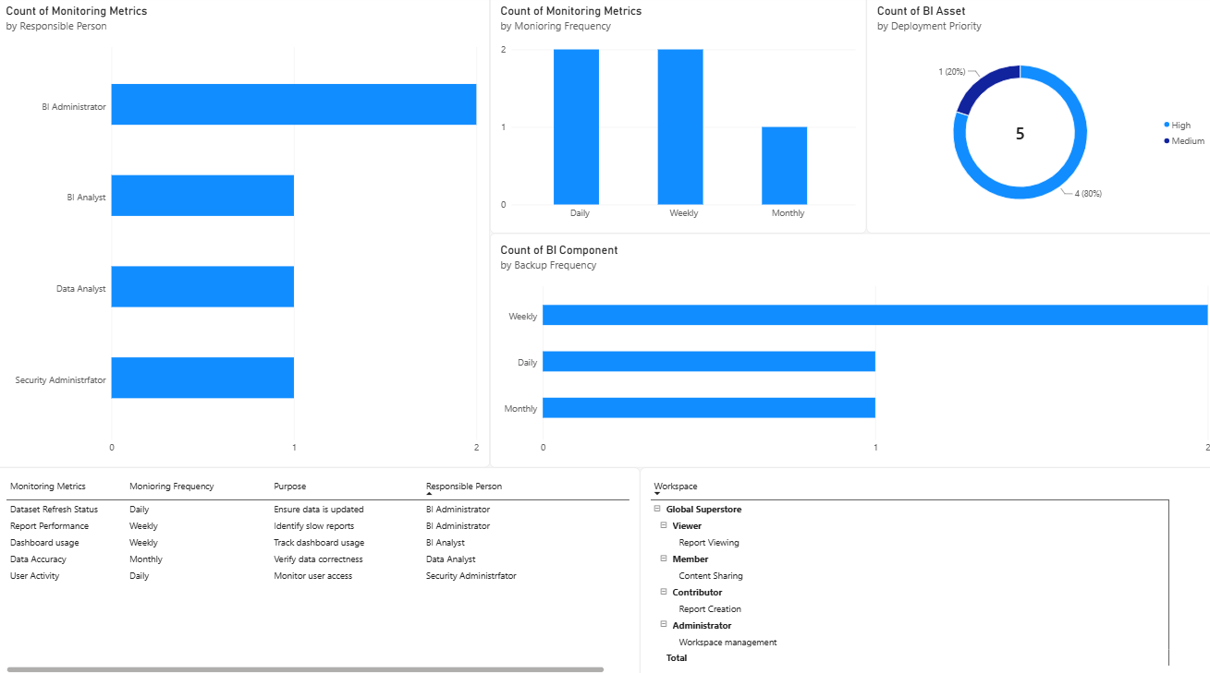

Result
A complete BI deployment, monitoring, backup, and recovery strategy was successfully designed. Deployment plans, monitoring procedures, workspace structures, and backup mechanisms were developed to ensure reliable and secure BI operations.

Learning Outcomes
• Analyze deployment requirements for Business Intelligence solutions. (CO4-BT4)
• Design workspace structures and governance models for BI systems. (CO5-BT6)
• Evaluate monitoring requirements for deployed BI solutions. (CO4-BT4)
• Develop backup and recovery strategies for business continuity. (CO5-BT6)

